Practical : 15

## Aim: Use various tags in Web.config file for ASP.NET configuration.

Home.aspx

<%@ Page Language="vb" AutoEventWireup="false" CodeBehind="Home.aspx.vb" Inherits="Practical_15.Home" %>

<!DOCTYPE html PUBLIC "-//W3C//DTD XHTML 1.0 Transitional//EN" "http://www.w3.org/TR/xhtml1/DTD/xhtml1-transitional.dtd">

<html xmlns="http://www.w3.org/1999/xhtml">

<head runat="server">

<title></title>

</head>

<body>

<form id="form1" runat="server">

<div>

<asp:TextBox ID="TextBox1" runat="server"></asp:TextBox>

</div>

</form>

</body>

</html>

Home.aspx.vb

Public Class Home

Inherits System.Web.UI.Page

Protected Sub Page_Load(ByVal sender As Object, ByVal e As System.EventArgs) Handles Me.Load

Response.Write(ConfigurationManager.AppSettings("Title"))

Response.Write("</br>Website Version : " & ConfigurationManager.AppSettings("Version"))

End Sub

End Class

Web.config

<?xml version="1.0"?>

<configuration>

<system.web>

<pages theme="Green" />

<compilation debug="true" strict="false" explicit="true" targetFramework="4.0" />

</system.web>

<appSettings>

<add key="Version" value="3.2.0"/>

<add key="Title" value="My Name is Ishan"/>

</appSettings>

</configuration>

Green.skin

<asp:TextBox runat="server" BackColor="Green" ForeColor="White" />

Output :

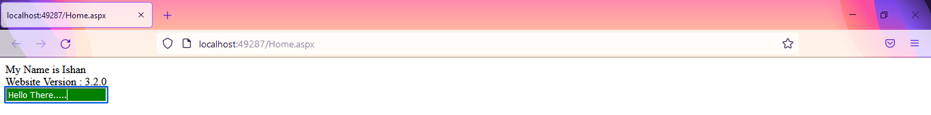

|  |  |  |  |
| --- | --- | --- | --- |
| Start Date | End/Sign Date | Faculty Sign | Remarks/Grade |
|  |  |  |  |